Organization Name:  Address:  CONTACT PERSON: <Name and Title>  PHONE (WORK):  PHONE (CELL):  E-MAIL:  - Harlem Children’s Zone, Inc. Model Sharing: Which model Sharing experience  - are you interested in? (Contact practitioners Institute Team for additional  - information)  VIRTUAL OFFERINGS (COST WILL VARY)  - 30-Minute Q&A (No presentation or Overview)  - 1-Hour Information Session (HCZ Overview, History and Culture) No fee.  - 2-Hour Program Presentations (Overview and 1-2 Specific Areas of Interest)  - 4-Hour Program Presentations (Overview, 2-4 Specific Areas of Interest, Deep Dive Q&A)  - Gold Star 4-Hour General Opening the Vault (Project activities, planning, and scheduling with breakout sessions)  VISIT OFFERINGS  - 1-Hour Information Session (HCZ Overview, History and Culture. No visit to programs.) No fee. Conversation only  - 3-Hour Site Visit (For groups of 6-12 people only) $3,000. Program Presentations with option to visit program(s)  - 1-Day Workshop (For groups of 6-12 people only) $6,000. Program Presentations with site visits  - 2-Day Workshop (For groups of 6-12 people only) $8,000. Program Presentations with site visits  - 3-Day Workshop (For groups of 6-12 people only) $10,000. Program Presentations with site visits | Organizational Information:  Please check one:  - Domestic (U.S.A.)  - International  Please select your organization type:  - Community-Based Organization  - Local Education Institution  - Government Representative  - Foundation or other funding sources  - Other (please list)

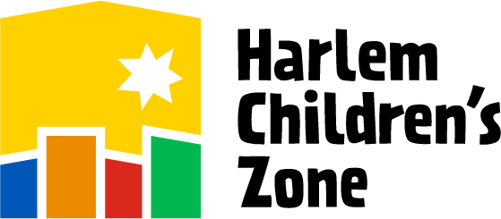
PRACTITIONERS INSTITUTE

INQUIRY FORM
 | Name | Job Title and Organization/Affiliation(s) | E-Mail Address
1
2
3
4
5
6
7
8
9
10
11
12
For physical visits, please list any food allergies or physical challenges participants may have:

Note: Please fill out the information for each participant and the organization background information below (especially if a collaboration of organizations is requesting to come for a visit).

Organization Background Information
Please describe the neighborhood/community you currently serve/intend to serve? (size, economic status, density, etc.) | <Please type your response here>
What is your organization/community’s strength(s)? | <Please type your response here>
Why is the organization coming on a visit? | <Please type your response here>
Briefly describe the organization(s) that will participate in the visit to the Harlem Children’s Zone. | <Please type your response here>
How many years has your organization been in existence? | <Please type your response here>
What is the budget size of your organization? | <Please type your response here>
What are your primary funding sources (% Private and/or Public)? | <Please type your response here>
How many employees (Full-time and part-time)? | <Please type your response here>
What element(s) of the Harlem Children’s Zone model most interest you, and why? | <Please type your response here>
How did you hear about the Harlem Children’s Zone, Inc? (60 Minutes, Ted Talks, New York Times, etc.)? | <Please type your response here>
Are you affiliated with any federal initiative (i.e., Promise Neighborhood, Choice Neighborhood, NRI, etc.)? | <Please type your response here>

Please e-mail your completed application to
Harlem Children’s Zone’s Practitioners Institute:
puser@hcz.org or fax at (212) 289-0661

If you have any questions, please call (212) 360-3274

